Pink weekend Game Plan
I recommend making it an online only sale. That way, people cannot order your packaged gift sets. You will be discounting your wrapping and packaging supplies and potentially losing money. However, if someone does call or text me with their order I do take it. A sale is a sale!

When possible, hand deliver all orders with the intent of getting in front of your customer. It allows you to see, thank her, and build rapport. Look for ways to show her what’s new or book a holiday makeover. Since Pink Friday involves heavy discounts, we want to make sure that we aren’t just stopping after the sale. Use this as a way to drum up business for December.

The $10 New Year’s Gift for every $100 ordered is a $10 gift card is one way that I use Pink Friday to increase future sales. I prep them all after my Pink Friday sale while the info is still fresh in my mind. Do what you can to make it look like a present when it arrives in the mail – cello bag, shred, festive envelope, etc. I drop them in the mail mid-December and follow up on December 26th to remind them of their gift card and to book appointments for January.

I do offer the 50-50 Deals along with the Pink Friday specials. It’s a great way to upsell, and to get your customers using more MK products. You are selling them at cost so you lose nothing, but you have a lot to gain with the extra sales.
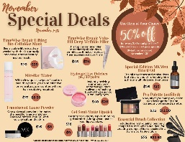

Your Pink Friday should always be your biggest sale of the year. It is the only time that your entire store goes on sale and for a flat percentage. You especially do not want your Small Business Saturday or Cyber Monday Sale to be a bigger discount than your Pink Friday Sale.

Cyber Monday is great because people go back to work and they shop online all day! It’s also great if a customer contacts you for an order but she didn’t get it in in time for your Pink Friday discount. I always felt bad when this would happen (especially if it was one of my PCPs) and I would feel the need to give her the full Pink Friday discount. However, this trains your customers not to respect deadlines and it’s also unfair to everyone who did shop on Friday. Now if someone contacts me about missing the sale I simply say, “No worries girl! We have 10% off for Cyber Monday! In fact, it’s already active right now on my website so you’ll still get a deal!”
Timeline:
Friday November 19th – Post “It’s Coming” Pink Friday Image
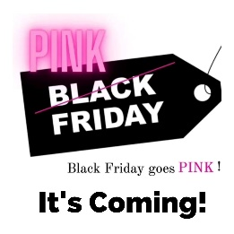

Saturday November 20th – Post “Pink Friday Is Coming” Elf Image

Sunday, November 21st – Post “5 Day Countdown Image”
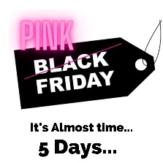

Monday November 22nd^{th} – Send Save the Date JPEG in text, email, and post in your group.
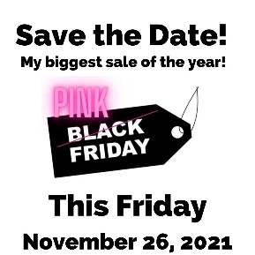

Tuesday, November 23rd – Post save the date on your business page again with the header “It’s Coming in 3 days!!!” Change the discount on your Personal Website to 25%. Do this by going to www.marykayintouch.com, Business Tools, Personal Website Manager, Update, then keep clicking through the screens until you see where you can add a discount. After the discount is set, then post, email, & text the VIP Customer Magical Script (see below)
Send the VIP Text to your PCP Customers. Set your website to 25% Discount. They will have to be logged in to have the discount applied.

Wednesday, November 24th – Post save the date on your business page again with the header “It’s Coming in 2 days!!!”

Thursday, November 25th – Set your phone alarm for 6am, 10am, and midnight to remind you to log in and change the percentage discounts on your Mary Kay Personal Website to 20%, then 15%, then change it to 10% at midnight.
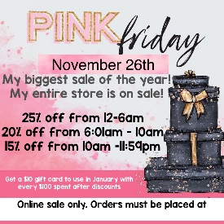

Friday, November 26th – Be sure to change your discounts at 6am and 10am and midnight.

Saturday, November 27th – Leave the discount at 10% for Small Business Saturday. Text, Email and post the flyer. (You may also use the alternate promo where it gives discounts based on how much they order. If you do this, remove all discounts from your website for Saturday.)
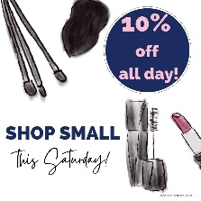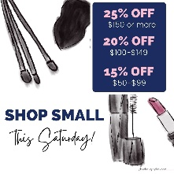
Sunday, November 28th – Email and text the Cyber Monday image.

Tuesday, November 30th – reset your website to show no discount

The VIP Customer Magical Script (Be sure to attach the Pink Friday Sale Image):
Hi Melissa! Just wanted to give you a heads up – this is my Pink Friday Sale that’s happening this week. You’re one of my VIP Customers so you don’t have to stay awake to get the 25% off. The sale is live for you right now on my Mary Kay website. Just log in and you will see the 25% discount at checkout.

This is my last big sale of the year. It’s a great time to stock up on your favorites or start your holiday shopping!

I hope that you have a very Happy Thanksgiving! I’m thankful for your business and I appreciate you being so loyal to me for so long. It makes a difference for my family and we appreciate it!
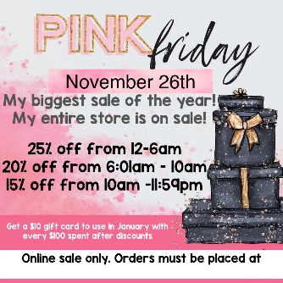

Bonus Thank You Posts:
To take it up a notch, you may post a thank you on your customer’s Facebook page to thank them for shopping your sale. This is a way to recognize her as well as for her friends to see that she uses Mary Kay.
